Driving the setup using Arduino with 5V, 200Khz.

Ch1 is across half a transformer coil, Ch2 is fish finder output

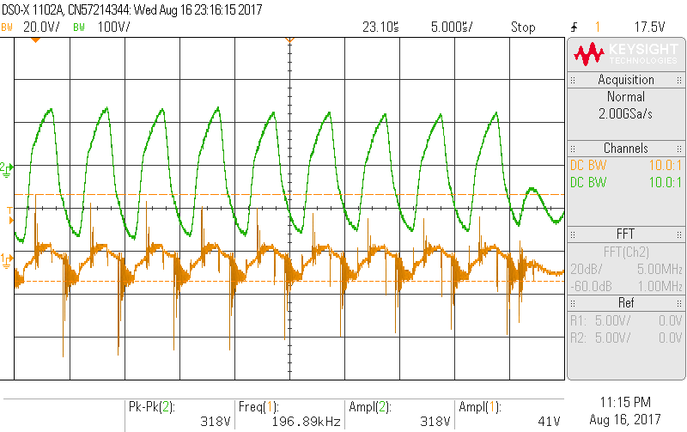

Zoom in on ring of transformer.

